Ensure that this file does not contain any information identifying the authorship of the article, including citations and references.
Use this file as a template for standardizing the article.
The article must be between 5,000 and 9,000 words, including abstracts and keywords in Portuguese, Spanish, and English, as well as footnotes and references.

Title and subtitle in English
Arial, size 12, bold, and right-aligned

Title and subtitle in Portuguese
Arial, size 12, bold, and right-aligned

Title and subtitle in Spanish
Arial, size 12, bold, and right-aligned

Abstract in English: The abstract text must contain a minimum of 180 words and a maximum of 250 words. Format the text in Arial font, size 8, justified alignment, and single line spacing.

Keywords: Word 1; Word 2; Word 3; Word 4.
Each keyword should start with an uppercase letter and be separated by a semicolon.

Abstract in Portuguese: The abstract text must contain a minimum of 180 words and a maximum of 250 words. Format the text in Arial font, size 8, justified alignment, and single line spacing.

Keywords: Word 1; Word 2; Word 3; Word 4.
Each keyword should start with an uppercase letter and be separated by a semicolon.

Abstract in Spanish: The abstract text must contain a minimum of 180 words and a maximum of 250 words. Format the text in Arial font, size 8, justified alignment, and single line spacing.

Keywords: Word 1; Word 2; Word 3; Word 4.
Each keyword should start with an uppercase letter and be separated by a semicolon.

Subtitles

Subtitles should not be numbered, must be aligned to the left, and have no indentation relative to the page margin. They should be formatted in Arial font, size 9.5, bold, with 1.5 spacing between the subtitle and the body text. It is mandatory for articles to include a section titled "Introduction" and another titled "Final Considerations," in addition to other sections and their respective subtitles, as determined by the specific characteristics of each article.

Body of the Text

The first line of each paragraph must have a 1.5 cm indentation relative to the page margin. The text should be aligned to the left, with 1.5 line spacing and Arial font, size 9.5. The spacing between paragraphs must be the same as the line spacing of the text.

Titles of Works (films, other audiovisual productions, books, etc.)

Capitalize only the first word. When mentioning titles in the body of the text, italicize them. Examples: Os homens de barro (2011), by Ariano Suassuna; Dona Flor e seus dois maridos (Bruno Barreto, 1976).

Words in Italics

Italics are recommended for foreign words and neologisms. Do not use underlining or bold to emphasize words in the text.

Footnotes

Footnotes should be formatted without indentation in the first line of the paragraph, using Arial font, size 8, justified alignment, and single line spacing. Website links and full bibliographic references must be listed exclusively in the "References" section at the end of the article. Note: Do not use endnotes.

Citations

Direct quotations must be accompanied by a reference in accordance with the updated ABNT NBR 10520:2023 standard, following these examples: (Author, year, p.) or Author’s Name (year, p.). Indirect quotations should follow the format Author’s Name (year) or (Author, year).

When citing films or other audiovisual works, use the format: Title of the film (year) or (Title of the film, year). For analyses of specific segments of films or other audiovisual works, indicate the time of the excerpt using the following examples: (between 09min50s and 10min30s) or (between 1h50min and 1h52min). All films or other audiovisual works must be included in the References section at the end of the article.

Quotations of up to four lines should be enclosed in quotation marks (“ ”) and integrated into the paragraph in the body of the text. For quotations within quotations, use single quotation marks (‘ ’). Quotations exceeding four lines must be presented in a separate paragraph, with a 4 cm indentation from the margin, in Arial font, size 9.5, and 1.5 spacing, following the main text format.

Images (Figures, Tables, and Charts)

Images (figures, tables, and charts) must be numbered and accompanied by captions and source information. They should be separated from the main text by two spaces above and below, positioned within the page margins, and centered. Captions and source information must be placed directly below the image, centered, in Arial font, size 8, with single line spacing. See the examples below:


Figure 1: Rebeca Icon. Source: Journal's website.

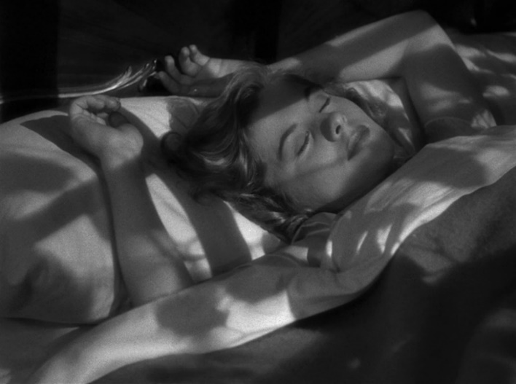
Figure 2: Lights and shadows of dawn. Source: Still from the film Rebecca (Alfred Hitchcock, 1940).

The caption should include a brief description of the image, while the “Source” must indicate the origin of the research material. Examples: Source: Stills from the film [...], Source: Reproduction from the website [...].

Analyzed images must be referenced throughout the article using parentheses, for example, (Figure 1).

In addition to including the images in the body of the text for evaluation, each file must also be submitted separately, properly identified with its numbering and caption, in a minimum resolution of 300 dpi, as supplementary material for the submission process.

References

References must be written in alphabetical order, with justified alignment, in Arial font, size 9.5, single line spacing, and one space between each reference. Formatting should follow the ABNT NBR 10520:2023 standards. Use bold for titles.

- Book

LAST NAME, First name of the author; LAST NAME, First name of the second author (if applicable). Title in bold: subtitle (if any). Edition number. City of publication: publisher, year.

[More than 4 authors]

LAST NAME, First name of the first author et al. Title in bold: subtitle (if any). Edition number. City of publication: publisher, year.

[Chapter in a book – different authorship]

LAST NAME, First name of the chapter author. Title of the chapter. In: LAST NAME, First name of the book editor or organizer (ed.) or (org.). Title in bold: subtitle (if any). Edition number. City of publication: publisher, year. v. (volume, if any) p. (starting page – ending page).

[Chapter in a book by the same author as the complete book]

Example:

MBEMBE, Achille. The little secret. In:______. Critique of Black Reason. São Paulo: n-1 edições, 2018. p. 185-227.

- Journal and/or Newspaper Article
LAST NAME, First name of the author. Title of the article: subtitle (if any). Title of the journal: subtitle of the journal (if any), city of publication (if any), v. (volume), n. (issue), p. (starting page – ending page), month and year. Available at: (if available, preferably include the DOI – Digital Object Identifier link). Accessed on: (day/month/year).
Example:
VALLEJO, Aida. Film Festivals: In the Spotlight of Film Historiography. Secuencias, Madrid, n. 39, p. 13-42, first semester of 2014. Available at: https://revistas.uam.es/secuencias/article/view/5838. Accessed on: 16 Dec. 2024.

- Conference Proceedings
LAST NAME, First name of the author. Title of the work: subtitle (if any). In: Name of the event, number, year, location. Electronic proceedings [...]. City of publication: publisher (if any), year, p. (starting page – ending page of the work). Available at: (publication link). Accessed on: (access date).

- Interview
[Written]
LAST NAME, First name of the interviewee. Title of the interview. [Interview given to] Name of the interviewer. Title of the journal, place of publication, volume, issue number, p. (starting and ending page of the article), month, year of publication. Available at: (publication link). Accessed on: (access date).

[Video]
Example:
PAIVA, Samuel. The Road Movie in Brazil - Samuel Paiva. [Interview given to] Significação Journal. YouTube, December 14, 2018, 8 min. Available at: https://www.youtube.com/watch?v=CbL-S3_LWeQ. Accessed on: June 17, 2024.

- Academic Work (Dissertation and Thesis)

LAST NAME, First name of the author. Title of the work. Year of submission. Thesis (Doctorate). Name of the educational institution (University), Location (City), year of submission.

- Audiovisual

[Film]
The TITLE of the work (first word and article in UPPERCASE). Directed by: (first and last name). Production (optional – Production or another relevant element for the article): (name of the production company or individual). Country: (country or countries), year. Physical format (if applicable), Duration in minutes, sound [sound or silent], color [color or black and white].

Examples:
VOICES Distant. Directed by: Terence Davies. Production: British Film Institute (BFI); Channel Four Films; Zweites Deutsches Fernsehen (ZDF). United Kingdom; West Germany, 1988. DVD, 84 min., sound, color.
DONA Flor and Her Two Husbands. Directed by: Bruno Barreto. Screenwriters: Jorge Amado, Bruno Barreto, and Eduardo Coutinho. Brazil, 1976. 110 min., sound, color.

[Internet Video]
The TITLE of the video (first word in UPPERCASE). YouTube (or platform name). Published by the channel (channel title), posting date. Available at: (video link). Accessed on: (access date).

Example:
THE EXTRACTION of minerals (1970). YouTube. Published by: Arquivo Nacional, December 22, 2017. 1 video (8 min.). Available at: https://www.youtube.com/watch?v=211dUfwtPCY. Accessed on: July 26, 2024.

[Series – Complete]
Example:
TRAINWRECK: Woodstock 99. Directed by: Jamie Crawford. Produced by: Cassandra Hamar Thornton and Sasha Kosminsky. United States, 2022. Series aired on Netflix [01 Season; 03 episodes], 143 min., sound, color. Available at: https://www.netflix.com/br/title/81280924. Accessed on: December 7, 2024.

[Series Episode]
Example:
MEMPHIS. In: THIS Is Us. Created by: Dan Fogelman. Directed by: Glenn Ficarra, John Requa. Produced by: NBC. United States: 2017. Series aired on Amazon Prime [Season 1, Episode 16], 45 min., sound, color. Available at: https://www.primevideo.com/detail/0GDP096ORVZ7V5R0WBBSDP04G5/ref=atv_dp_season_select_s1. Accessed on: December 7, 2024.

- Audio

[Podcast]
NAME of the Podcast: title of the episode. Interviewee: (person's name). Interviewer: (interviewer's name). Location (city): producer, day, month, and year. Podcast. Available at: podcast link. Accessed on: (access date).
[Music]

LAST NAME, First name of the performer or composer of the music. Title of the song. City: Record label: year. Format (duration in minutes). Available at: (access link). Accessed on: (access date).

Examples:
GIL, Gilberto. Drão. Rio de Janeiro: Warner Music, 1982. Track 7. 1 Vinyl record.

MOZART, W. A. Mozart Requiem Mass in D Minor VI: Confutatis and Lacrimosa [1971].
Available at: http://www.youtube.com/watch?v=CQUFQ_N0JI8&NR=1. Accessed on: April 12, 2008.

- Document Accessible Exclusively in Electronic Format
LAST NAME, First name of the author. Title of the document. Version or edition (if applicable). City of publication, date, description of the electronic medium.

- Social Media

LAST NAME, First name of the user. Title or text of the post. City (if applicable), day, month, year. Name of the social network (Twitter, Instagram, Facebook, etc.): @username. Available at: (access link). Accessed on: (access date).

- Cases Not Covered in This Style Guide
For reference formatting, use the ABNT NBR 10520:2023 standard. Available at: https://usp.br/sddarquivos/arquivos/citacoes10520.pdf

Article received on: XX/XX/XXXX and approved on: XX/XX/XXXX.

